Name: Varsha Pravin Dalvi 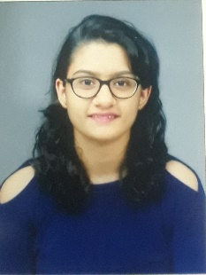
Phone: 8805879423
E mail: dalvivarsha2207@gmail.com
Career objective
Energetic professional seeking creative law based role to work with on daily basis updating skills and building reputation of the firm or company and achieving success
Professional Efficiency
-Diligent and active
-Convincing ability
-Excellent interpersonal skills
-Excellent oral and verbal communication
-Eye for detail
-Disciplined
Computer Skills
-Windows 10
-Power Point
-Microsoft Excel, Word
-Government websites like Income tax, Ministry of Corporate Affairs, IPR, GST, etc
Intership
Experience of 12 months at M.S.Huparikar and Associates (Working)
Responsibilities
Handled and have experience in Incorporation of Private Companies, Nidhi Companies, Producer Companies, Section 8 Companies, Annual fillings, Legal Drafting of Partnership Agreements, Franchise Agreements, Resolutions, Appointment and Removal of Directors, Gst Filing, Share Transfer, Trademark Applications and other legal compliances of company

Education Qualification
YEAR | COURSE | INSTITUTE | MARKS OBTAINED
2013-2014 | SSC | RADHABAI SHINDE ENGLISH MEDIUM SCHOOL | 86%
2015-2016 | HSC | DRK COLLEGE OF COMMERECE | 76%
2018-2019 | BSL | SHIVAJI UNIVERSITY | 58%
2020-2021 | LLB | SHIVAJI UNIVERSITY | 88%
2018-2019 | CS FOUNDATION | ICSI | 211/400
2020-2021 | CS EXECUTIVE  (Module 1) | ICSI | 201/400  Appearing for 2nd module
Personal Details
-Date of birth: 22/07/1997
-Languages known: English, Hindi, Marathi
-Hobbies: Reading, Dancing, Cooking

