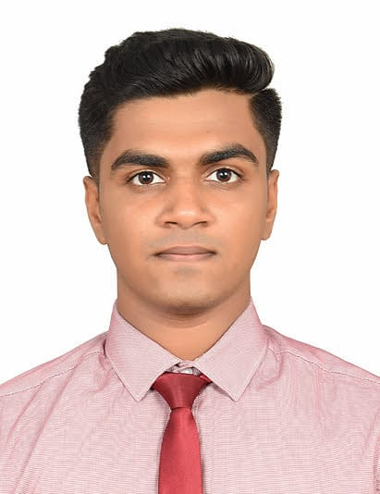

MABEN SHANE
CIMA Cert BA.| B.B.A.

Phone: +919620858236 Email: shane.maben77@gmail.com
Linkedin: https://www.linkedin.com/in/maben-shane-36718019a
Karnataka, Mangalore.

Profile
A proactive Part qualified CIMA U.K. Aspirant and a recent graduate in Bachelors of Business Administration with sound business acumen and strong academic achievement. Equipped with professional knowledge in accounting, business operations and financial services. Possess strong leadership and communication fluency in English, Tulu and Kannada. Eager to learn more and accept challenges with an “I can” mindset continuously seeking to enhance skills and knowledge.

Professional Qualifications and Memberships
Chartered Institute of Management Accountant (CIMA UK) | Part Qualified - 01/2020 to Present

Cleared the Certificate level and has acquired the CIMA Certificate in Business Accounting (CIMA Cert BA).
Currently pursuing to acquire the CIMA Diploma in Management Accounting.

Able to practice and decide on major accounting, auditing and financial concepts such as:
- Financial Reporting (IFRS and IAS)
- Cost and Management Accounting
- Financial Management
- Budget Forecasting and Preparation
- Short term Commercial decision making
- Short term Risk and Uncertainity
- Trend Analysis
- Variance Analysis
- Finance in Digital world
- Working Capital Management
- Fundamentals of Ethics, Corporate Governance and Business Law.

Key Skills and Achievements
- Client Capture and Management: Encouraged potential candidates to enroll in CIMA and provided significant amount of training and in turn helping them to clear their exam.
- Continuous Improvement: Driven by the concept of Kaizen, ensures no time is left idle by gaining relevant technical skills and acumen needed in the present industry; utilized lockdown to participate in virtual experience programs in top companies such as BCG in Strategic consultancy.
- Leadership: Lead various Music Bands and Organized events, preparing budgets and brainstorming ideas. Elected as the leader of the Association Group In College
- First class communication and presentation skills: Lead in Front of 600 people and presented in various groups and association. Helped friends and families in guiding them.

Education
- Chartered Institute of Management Accountant (CIMA), UK (Pursuing)

- Bachelors of Business Administration (B.B.A.) Specialized in Human Resource– 06/2018 to 09/2021
St. Aloysius College, Mangalore, India.

First Class; Cumulative Grade Point Average in percentage: 76.46%

- Sharjah Indian School, Sharjah, UAE
Central Board of Secondary Education

Grade 12: 81.1%
Grade 10: CGPA 8.2 (out of 10)

Technical Skills
- MS Office (Word, PowerPoint, Excel)
- Power BI
- Tally ERP9
- SAP FICO
- Peachtree
- QuickBooks

Extra-Curricular and Academic Activities
BCG Strategy Consulting - Virtual Experience Program 2020 | 6-8 Hours
Participated in the open access BCG Virtual Experience Program with Forage
Modules Completed
- Module A
- Module B
Management fest
Organized an event round in the management fest
Member of Music Association
Member of Sahaya (Help) group- social work

Certifications
CGMA: Digital Mindset Pack
CGMA: Block Chain
CGMA: Robot Process Automation
Power BI for Financial Reporting and Financial Analysis.

Languages
English – Proficient
Hindi – Fluent
Tulu – Native
Kannada- Native
Arabic – Beginner
French - Beginner

