SILIGURI INSTITUTE OF TECHNOLOGY COLLEGE OF HOTEL MANAGEMENT & CATERING TECHNOLOGY

CURRICULUM VITAE

Name : UDBBHAS DUTTA |  |  |  |  |  |  |  |  |  | 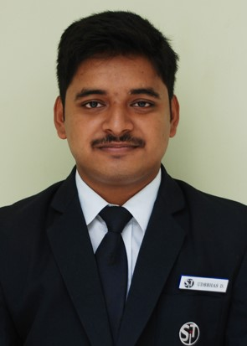
Career Objective: To work effectively within a growing organization that offers challenges and the opportunity to grow with the company. I wish to contribute my current skills attending to clients' needs and maintaining a professional demeanor to your company because I respect the professional environment in which goals and objectives are clearly established and the tools to reach such goals are provided.
Area of Interest | Major: Frontoffice  Minor: Food and beverage service
Educational Details  (Latest Qualification First) | Examination |  | Duration |  |  |  | Board / Council / University |  |  | Marks obtained (in %)
Educational Details  (Latest Qualification First) |  |  | From |  | To
Educational Details  (Latest Qualification First) | BHMCT |  | 2017 |  | 2021 |  | MAKAUT(SIT) |  |  | 8.53 GPA
Educational Details  (Latest Qualification First) | 10+2 |  | 2016 |  | 2017 |  | CBSE(KVS) |  |  | 69.6%
Educational Details  (Latest Qualification First) | 10 |  | 2014 |  | 2015 |  | CBSE(KVS) |  |  | 77.9%
Professional Qualification | Completed 6 months industrial training from THE LEELA,GOA in all the 4 major departments  Departmental manager in training at reliance retail,Gujarat
Other Qualifications / Skill Sets | BASIC KNOWLEDGE OF COMPUTER SKILLS  MS OFFICE  DBMS  Dedicated to the work assigned
Language Proficiency |  | ENGLISH |  |  |  | HINDI |  |  |  | BENGALI
Language Proficiency |  | Read |  | Write | Speak | Read |  | Write | Speak | Read | Write | Speak
Language Proficiency | Excellent | Y |  | Y | Y | Y |  | Y | Y |  |  | Y
Language Proficiency | Good |  |  |  |  |  |  |  |  | Y | Y
Language Proficiency | Average

Seminars/ Conferences attended | PARTICIPATED IN A SEMINAR ON STRESS MANAGEMENT “HOW TO FACE THE CHALLENGES OF JOB STRESS” HELD BY SIT  PARTICIPATED IN A SEMINAR ON “FIRST AID” HELD BY SIT  PARTICIPATED IN A SEMINAR ON “MIND MANAGEMENT” HELD BY SIT  PARTICIPATED IN A COCKTAIL AND MOCKTAIL SESSION BY MONIN  PARTICIPATED IN A SEMINAR BY SULA VINEYARDS
Extra Curricular Activities/ Hobbies / Awards & Recognition | SECURED 2nd POSITION IN 100M DASH IN CLASS X  SECURED 1ST POSTION IN CLASS FOR 2ND SEM COLLEGE EXAM  PARTICIPATED IN “MASTER CHEF” COMPETITION HELD IN SIT  PARTICIPATED IN POSTER MAKING COMPETITION HELD IN SIT  HOBBIES- PLAYING CRICKET,READING NOVELS, LEARNING ABOUT DIFFERENT TYPES OF MARKETING AND BUSINESS
Personal Details | Father’s Name: KOUSTOV KUMAR DUTTA
Personal Details | Address: ATUL PRASAD SARANI, HAKIMPARA, SILIGURI |  |  |  |  |  |  |  |  |  | PIN : 734001
Personal Details | Contact No. 8250550612
Personal Details | Date of Birth |  |  |  |  |  |  |  | Gender | Nationality | Passport No. NA
Personal Details | 1 | 5 | 0 | 4 | 1 | 9 | 9 | 8 | MALE | INDIAN

I hereby declare that the above information is true to the best of my knowledge.

Date : 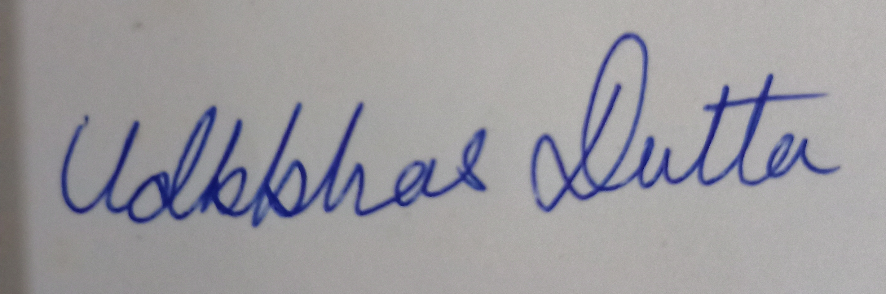

Place: SILIGURI (Signature)

