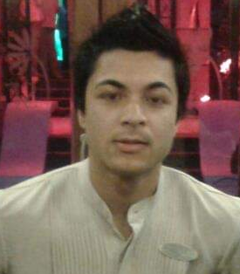
RESUME

PRANAY GHIMIRAY

ADDRESS: Primtam Road,
Kalimpong-734301,
District Kalimpong, West Bengal.

MOBILE NO. +91 8918554143 Email: p.ghimiray@gmail.com

Professional Summary:

A dedicated therapist who is passionate about health, beauty and healing in a Spa Setting with a range of qualifications in holistic therapy and beauty. Has a thorough knowledge of different beauty and therapy products and when/how to use these. Such as individual facial products and essential oils. Experienced in a wide range of treatments including reflexology, Indian Head Massage, Aromatherapy and Body Scrubs. Able to work under initiative and as a part of a team, always maintaining the working environment to a high standard of safety and cleanliness. Excellent communicator with patience and empathy and able to relate well to costomers. Always immaculately presented with excellent timekeeping skills. Very physically fit and resilient to standing and bending for long period of time during the treatments. Possesses a strong business focus and can work to meet targets along with sales team.

Core Qualification:

- Diploma Certificate in Western Spa and Hair Designing from VLCC Kolkata.

Academic Qualifications:

- Class X passed from S.U.M. Institution, Kalimpong, WBBSE in 2008.
- Class XII passed from S.U.M. Institution, Kalimpong, WBCHSE in 2010.

Key Skills:

- Multi skilled in a range of Holistic Therapy and Beauty Treatments.
- In depth knowledge of Western and Eastern Body Therapist.
- In knowledge of Aromatherapy, Swedish Massage, Balinese Massage, Deep Tissue Massage, Sports Massage, Thai Massage, Saitchu Massage, Indian Traditional Massages, Shirodhara Massage, Kizi Massage, Foot Reflexology, Body Scrub, Body Wrap, Moroccan Bath, Manicure & Pedicure and facials.
- Good communication skills with client.
- Product Knowledge and Sales Skills.

Professional Experiences:

- Work Worked as a Spa Therapist at Hyatt Regency Gurgoan, Delhi.
- Worked as a Spa Therapist Le Meridian Mahabalaswar.
- Worked as a Spa Therapist at Mayfair Spa and Casino Resort, Gangtok.
- Worked as a Spa Therapist at Vasant Continental Hotel, Delhi.
- Worked as a Technician at Urban Male Lounge, Dubai.
Personal Details:
- Father’s Name : Binod Ghimiray
- Mother’s Name : Santa Ghimiray
- Date of Birth : 15th October 1991
- Sex : Male
- Religion : Hindu
- Nationality : Indian
- Marital Status : Singal
- Languages Known : Nepali, Hindi and English.

Declaration:

I hereby declare that above information furnished by me are true and correct to the best of my knowledge and belief.

Pranay Ghimiray

