 SHAKIN AMARTHIYA PANDIAN S

508/Main road, karunyapuram

Kalanthapanai, Therku valliyoor

VALLIOOR-627117

THIRUNELVELI [DT]

Mobile: +919042001045

Email: shakinpandian1045@gmail.com

OBJECTIVES

A challenging position in the field of NDT Technologies in which my skills and +3 year’s experience in Ultrasonic Testing, Visual Testing may be effectively utilized to contribute and enhance company integrity reliability, Security and productivity.

EDUCATIONAL QUALIFICATION

- BE Mechanical Engineering

TECHNICAL QUALIFICATION

- ASNT-Level-II;

  - Radiography Testing,
  - Ultrasonic Testing,
  - Magnetic particle testing
  - Liquid penetrant testing
[ASPER ASNT – SNT - TC -1A - LEVEL II- 2016EDITION]

PCN - 3.1 (plate) 3.2(pipe)- UT

WORKING EXPERIENCE

1) Name of the company : SFL(TVS)(3 month)
Designation : UT TECHNICIAN
Duration : JAN 2020 to MAR 2020

2) Name of the company : LASEN & TOUBRO MODULAR FABRICATION(L&T)
CHENNAI
Project : 98/2 surf(Subsea Umbilical, Risers and Flow lines)
Designation : UT TECHNICIAN
Duration : April 2020 to till date

EQUIPMENTS HANDLED

UT : MODSONIC ENSTEIN (TFT, DGS)
MT : AC/DC& Permanent Yoke, Head shot method.
PT : Portable Kit (Visible &Fluoresce)

MAJOR RESPONSIBILITIES

- Identification of different types of raw materials related to specific job
- Visual inspection before testing .
- Thorough knowledge of isometric drawings of oil & gas & power generation plants.
- Computerized report preparations by using MS Word, Excel & Powerpoint.
- Thickness survey, Lamination survey, weld scanning by using UT method.
- Report closing after job finish.

EXPERIENCE SUMMARY.

  - Weld scanning more than 60mm thickness job
  - Beam (X,Y and Z joints), T ,TK and TKY joints in tubular and plate .
  - Well conversant with NDT methods such as UT, MPT, DPT etc.
  - Detection of corrosion and other service on various vessels ,pipelines.
  - NDT on various kinds of components like boiler tubes, pressure vessels etc.
  - NDT on various kinds of material like CS, SS, Al, Bronze etc.
  - Champer joints scaning, Double bevel, Single bevel Butt joints, Single V butt joints.

PERSONAL DETAILS
Name | : | Shakin Amarthiya Pandian S
Date of Birth | : | 02.12.1998
Marital Status | ` : | Single
Languages Known | : | Tamil and English
Passport No | : | U3601794
Date of Expiry | : | 05/11/2030

DECLARATION
I hereby declare that the above written particulars are true to the best of my knowledge and belief.

Date : Signature
Place : Shakin Amarthiya Pandian s
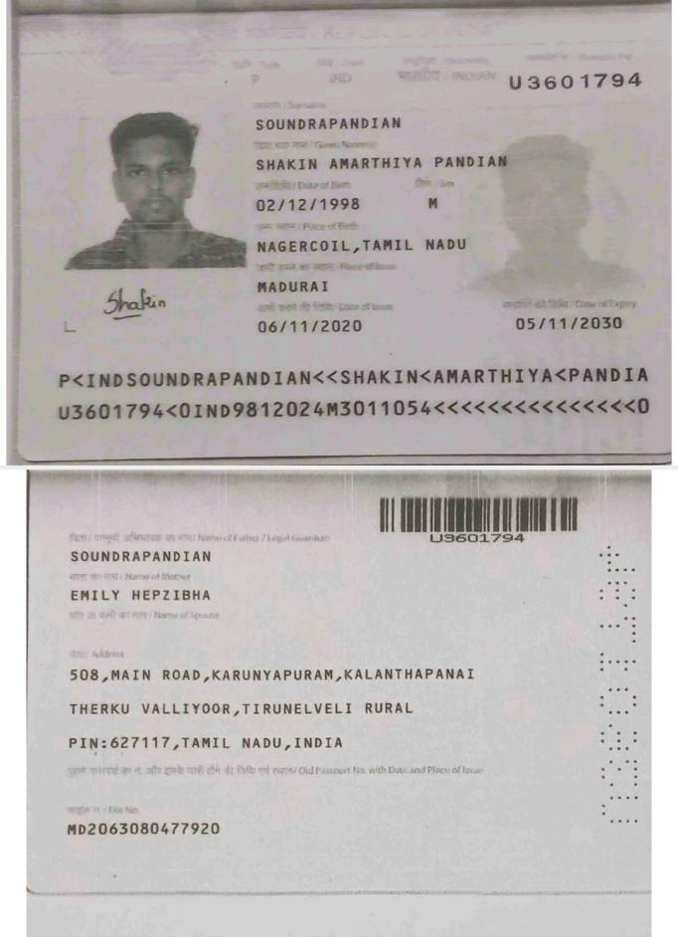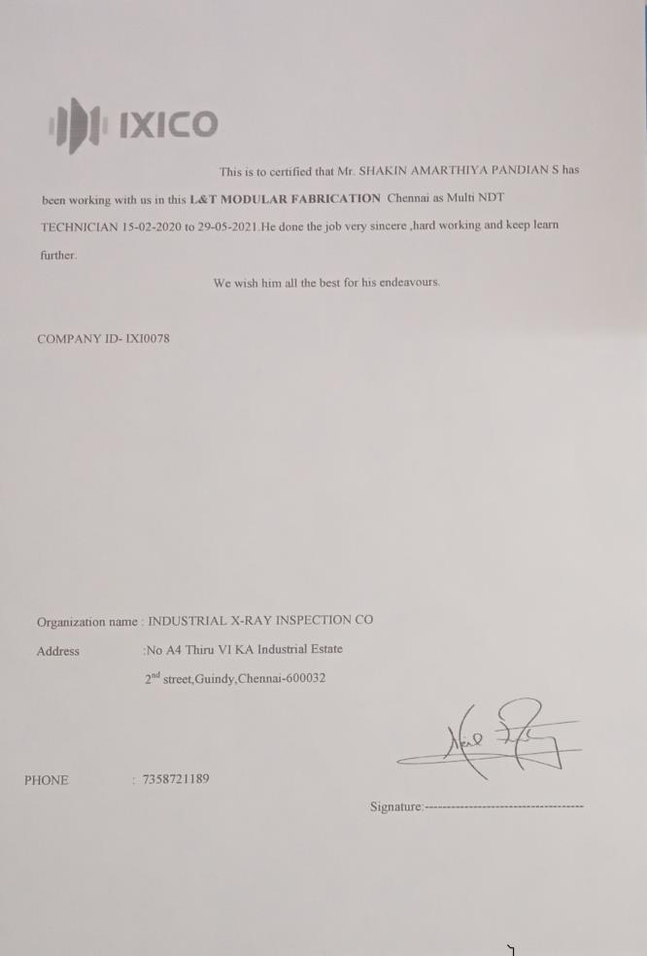

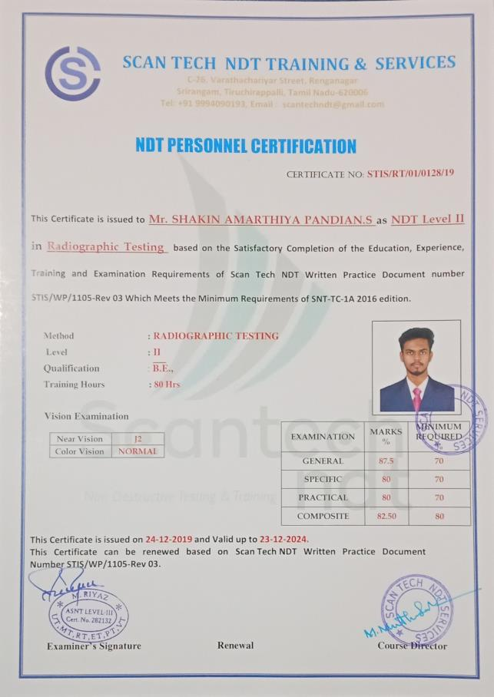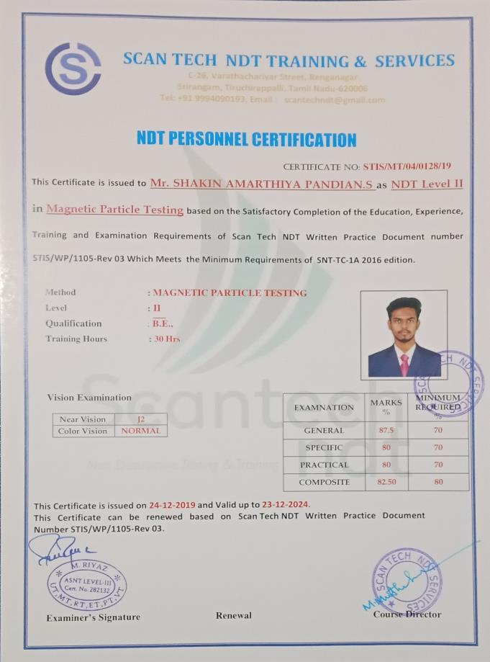
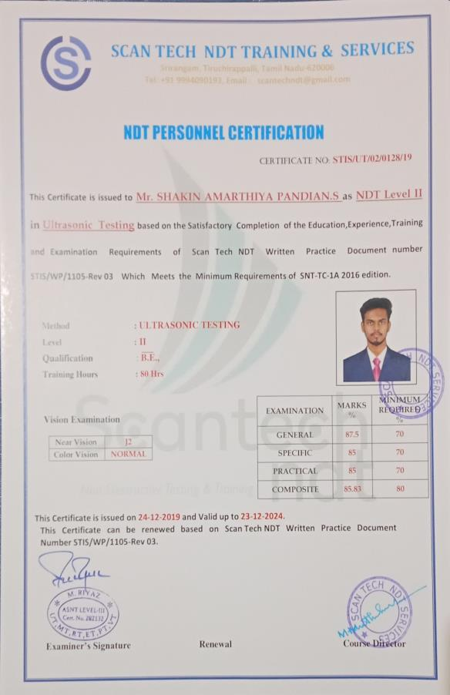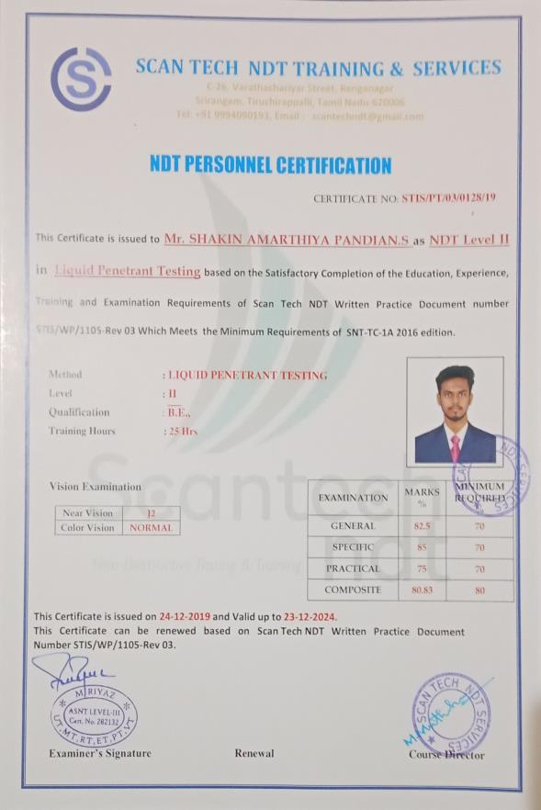

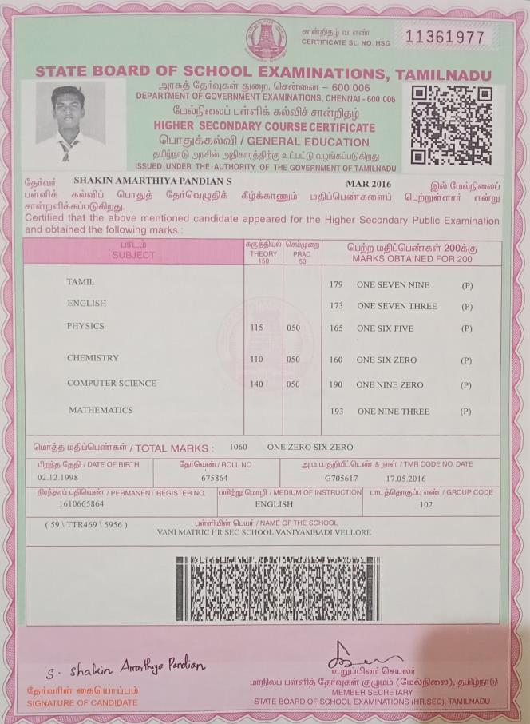
W