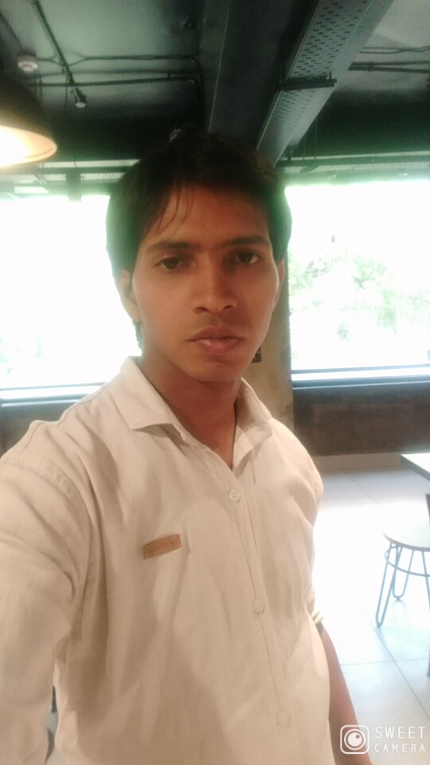
Name- Ajay Kumar
Address.- 5/549 Dakshin Puri Dr. Ambedkar Nagar sctor. 5
New delhi- 110062
Mob- +919818131626
Email address:- Rajaykumar743@gmail.com
*Career objective
To achive resposible and challenging position that will allow me to utilize my education and

* Education Qualiflcation
- 10 passed from C.B.S.E. Board
- 12 passed from C.B.S.E. Board
- Chip level & card level courses form Hi-tech
- Pursuing Graduation in B.C.A from (IGNOU)
*Work Experience
- 6 years experience in computer hardware in desktop & laptop repairing
- Basic knowledge of software
- Basically knowledge in networking
*Personal Details
Date of Birth- 26/05/1996
Father Name -Mr.Inderpal
Martial Status – Unmarried
Gender – Male
Religion- Hindu
Nationality- Indian
Languages known - Hindi and English
Date: Place:

Ajay Kumar

