Curriculum Vitae

MOHAMMAD IMRAN 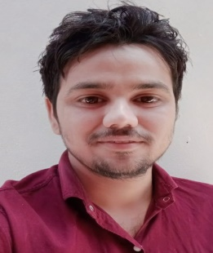 Gamharia, po- japla, Hussainabad, palamu, Jharkhand 822116 Email:- imran9128304549@gmail.com Contact:- 9128304549/8409940254

Objective:-
- To be associated with a progressive organization which can provide me with a dynamic work sphere to extract my inherent skills as a Professional, use and develop my aptitude to further the organization’s objectives and also attain my career targets in the progress.
EDUCATIONAL QUALIFICATION:-
S.N. | Name of Examination | Name of Institute | Board/ University | Year | Marks
01. | MRM | DORANDA COLLEGE RANCHI | Ranchi University | 2021 | 84%
02. | Graduation | A.K SINGH DIGREE COLLEGE | N.P.U. Medninagar | 2018 | 69%
03. | Intermediate (10+2) | S.B.S Inter college japla | JAC Board Ranchi | 2015 | 70%
04. | Matriculation | Bakshi high school japla | JAC Board Ranchi | 2013 | 73%

ADDITIONAL KNOWLEDGE:-

• Basic Computer Knowledge
*ADCA (Advance Diploma Computer Application)
From IACT Delhi

WORK EXPERIENCE-
: Moulana Azad edu-tech and trust ormanhi Block chock Ranchi
: Social Mobilization work ( Job Role as a project Manager )
: Work from ( 12/07/ 2018 to 09/08/2021 ).

HOBBIES:-

• Reading book
• travellig
. playing Cricket

Personal PROFILE:-

Name :- MOHAMMED IMRAN
Father’s Name :- Md. IRFAN
Date of Birth :- 04 July 1998
Address :- At- Gamharia,Chhatterpur road, PO:- Japla
PS:-Hussainabad, Dist-palamu
Jharkhand 82216
Sex :- Male
Marital Status :- Unmarried
Nationality :- Indian
Language Known :- Hindi, English,Urdu(Speak & Written)

Declaration:-

I hereby declare that the information furnished above is correct to the best of my knowledge.

Signature:-
