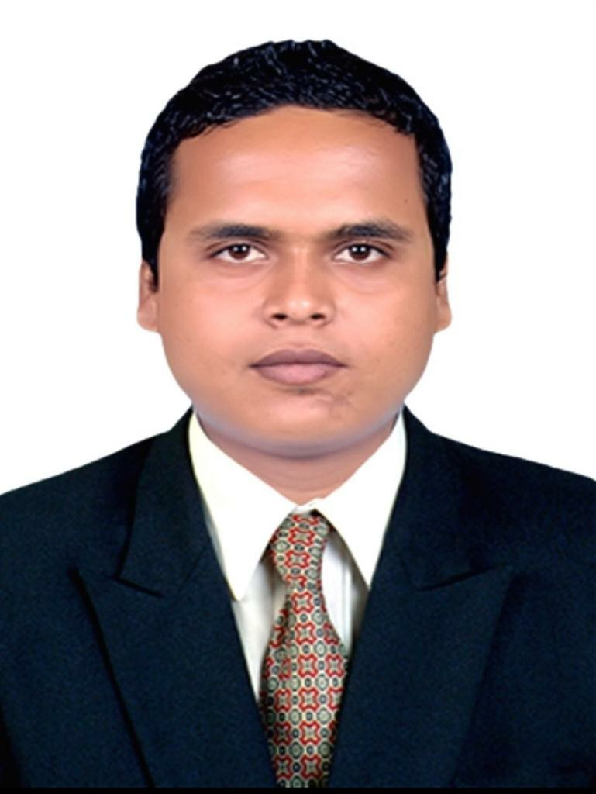
Aatrey Prasad Mandal
Royal Caribbean international
Aatrey.pm.23rd@gmail.com
Mobile:8292713128,9142435722

Objective :

To further my professional career with an executive level management position in a world class company.
Seek to diversify my skills in another industry and as part of a larger organization. Relocation desirable. Academic Details :

- Bachelor of science in Hotel Management [2011] with aggregate of 67% from SAMS INSTITUTE OF HOTEL AND BUSINESS MANAGEMENT,UTTAR PRADESH
- Intermediate of science [2008] with aggregate of 50.20% from ANNADA COLLEGE,HA ZARIBAGH • Senior secondary school [2006] with aggregate of 66.4% from Ccl High school,Barkakana Work Experience :
- Working as Facility cleaning in Royal Caribbean International from Nov 2016 to till date
Role :Taking care of rooms and all public area.
Providing guidelines to my juniors.
Taking care of guest comfort.
Handling the guest complains.
Responsible for housekeeping inventory.
Check Par stock of lenen and guest supplies and cleaning supplies on floor.
Communicate effectively with maintenance department to ensure timely repair all maintenance.
lead my team members as a good team leader for perfect work.
- Worked as Housekeeping Associate in The Address Hotel, Dubai Mall, Emaar groups of Hotels from
Aug 2015 to Sep 2016
Role :Responsible for cleaning guest rooms, corridor. maintaining the floor pantry.
responsible for cleaning supplies. responsible for room inventory.
Handover lost and found to the housekeeping desk with all necessary information, arranged all guest belongings in proper way. checking the all maintenance in the room. Responsible for the guest complains.
- Worked as Housekeeping Associate in Flora Creek Deluxe Hotels and Apartments, Dubai from Feb 2014 to Jul 2015
- Worked as a HOT and Housekeeping supervisor in Royal Retreat, Ranchi from 2013.
- Worked as Industrial trainee for all hotel departments in The Pride Hotel,Ahmadabad from Oct 2009 to Mar 2010
Field of Interest :

- I like to interact with customers and solve their problems.
Skills :

- Through working knowledge of equipment,materials and methods used in cleaning,excellent customer service,knowledge of maintenance rooms,bathroom and public area as well company standard,able to prioritize task and strong attention to details.
- Computer skill :-Microsoft Office,Microsoft word, PowerPoint,excel and IDS.
- Hardworking,comfortable working in group and highly active.
- I always try to enhance my personal growth with the organization growth.

dvcc
Achievements :

- Best trainee award from The Pride hotel,Ahmadabad on 25febuary 2010.
- Star of the month from Flora creek Hotel and Apartments,Dubai on 26december 2014.
- I have done training from GSNL(getting started as a new leader)
- I have done training from ALPS(accelerating leadership performance service)

dxcx
Strength & Hobbies :
- Excellent communication skill, quick decision making,function well in high pressure atmosphere and ability to lead,guide and motivate all levels.
- I like to talk people,playing cricket,swimming and cooking.

dcx
Declaration :

I hereby declare that the above written particulars are true to the best of my knowledge and belief.

gbgb

