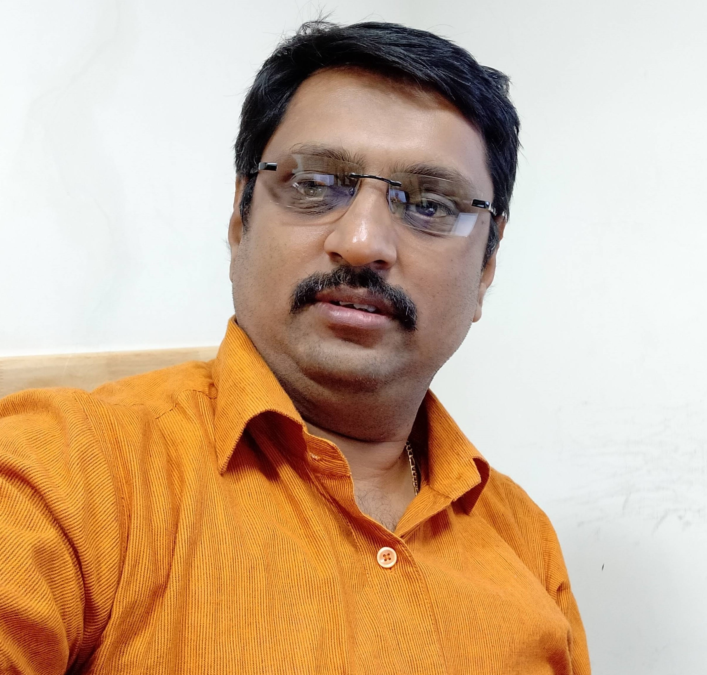 |  | Dilip Kumar B
Contact  PHONE: +91 94441 16863  EMAIL: sundilip@gmail.com  SPECIALTIES  - Earmark 100% of my resources to the organization  - Capable of taking up responsibilities and keeping a cool mind in the amidst of tough situations.  - Having an analytical mind and creative ability.  - Meeting personal targets by setting and prioritizing objectives and tasks.  - Self-motivated, enthusiastic, and maintaining a can-do attitude.  PROFESSIONAL HISTORY  - Vishwak Solutions Pvt. Ltd., Chennai – From October 2003 till date  - Badrachalam Paper Boards, Chennai – from May 2000 to September 2003  - S & S Power Switch gears, Chennai – from May 1998 to April 2000 |  | PROFESSIONAL PROFILE  - Over 20 years of work experience and around 12 years in Project Management  - Possess excellent Project management and adaptation skills, very organized, responsible with an attention to detail.  - Organized and takes initiative to be a leader, very logical, precise and analytical, Able to work unsupervised or in a team environment.  - Proven leadership abilities in working as a team, handling multiple tasks, great adaptability to any enterprise's environment.  - Possess excellent problem solving and analytical skills  - Ability to learn quickly and support new applications and systems  - Career oriented, hardworking and ability to handle multiple tasks  - Possess good time management and organizational skills  - Possess excellent communication and interpersonal skills  - Excellent team player with positive attitude  - Expertise in full project life cycle development for implementation and integration  key skills and characteristics  - Project Budget Management  - Excellent listener  - Friendly, courteous, and service oriented  - Poised under pressure  - Staff Training & Coaching  - Quality Assurance  - Solid written and verbal communicator

Education  - B.BA from University of Madras  - Diploma in Electronics  - Certificate course on VB6.0 & Oracle from Radiant Software.  Tech SKILLS  - Technology: Asp.net 4.0, 4.5, 4.5.1, 4.5.2, 4.6  - Database: MS SQL Server 2008,2012,2014, 2016  - Cloud Technologies: AWS services  - Worked on CDN’s like Akamai and Cloud front  - Web Tools: HTML  - Client Script: JavaScript, JQuery  - Web Server: IIS 10.0. |  | PROFESSIONAL EXPERIENCE  Project Title: News Portal Development and Management for a Leading Tamil News Bureau (Dina Thanthi).  Role: Project Manager  Vishwak Solutions Inc,  2015–Present  - Team Management  - Project Scoping  - Site enhancements  - Planning and execution of revamps and structural changes of site  - Site performance handling  - Capacity planning  - Handling content partner’s queries.  - Working on CDN (Content Delivery Network) Akamai and Cloud front  - Day to day Operations  - Maintaining performance checklist for smooth delivery  - Mobile Development – Requirement gathering and execution  - Android, iOS device mobile app validations  - Weekly reports  - Maintain the highest degree of integrity in our dealings.  - Live URL’s: https://www.dailythanthi.com  https://www.maalaimalar.com  https://www.thanthitv.com  https://www.dtnext.in  Project Title: Project management for seven language portal development Eenadu India Hyderabad.  Role: Project Manager  Vishwak Solutions Inc,  2011–2015  - Project development and management for seven language portals  - http://eenaduindia.com (English, Hindi, Kannada, Marathi, Gujarati, Bengali, Tamil)  - Project Scoping  - Team Management  - Project management for developing m. portal (six language portal)  http://m.eenaduindia.com  - Site performance handling  - Handling content partner’s queries.  - Working on Akamai Luna Control and Cloud front  - Day to day Operations  - Maintaining performance checklist for smooth delivery  - Weekly / Monthly reports

Project Title: MSN India and MSN SEA (South East Asia) News Portal Management

Role: Associate Project Manager

Vishwak Solutions Inc,
2008–2011
- Team Management MSN India Site overall Maintenance.
- Interacting with the client and taking up of Specs and getting it done with the help of the team.
- Handling customer issues and escalations
- Auditing of new releases for MSN India
- Working checklists for easy and flawless release.
- Planning and execution of structural changes of site – Preparing of checklists
- Handling content partners queries.
App Management – Release (Ensuring Quality – QERM, Ensuring Privacy aspects using PAM, Ensuring Legal aspects using LCA
- Working on App certification with the Corp team
- Handling feed integration for site as well as Apps

Project Title: Vodafone GPRS Portal Management

Role: Sr. Lead

Vishwak Solutions Inc,
2005–2008
- Preparing Scope for creating new tool which was used for Vodafone
- Deployment and release management.
- Vodafone live portal management.
- Planning and execution of structural changes of site – Preparing of checklists for doing an easy flawless transition
- Requirement gathering and Scope estimation.
- Interacting with the CP’s for solving issues related to XML Processing.
- Payment Gateway integration.
- Project Scoping for new tools development and Managing it.
- Handling customer issues and escalations
- Efforts to reduce product loss on the operations end
- And all other Assignments entrusted

Project Title: MSN India - Bedrock

Role: Portal Lead

Vishwak Solutions Inc,
2003–2005
- Worked on many assignments relating to improving the quality of Site.
- Qualitative analysis of Search using new search engine Inktomi
- SDLC release processScoping, estimation and release management for newly Working newly created MSN India specials.
- Configuring of the prioritized search result for the MSN India Created Specials.

Company: Badrachalam Paper Boards

Role: EDP in charge
2000–2003
- Using Wide Area Network Technology to connect between different warehouse.
- Daily Report Generation of the orders that have been processed at different warehouse and maintaining / preparing Cristal report.

Company: S & S Power Switch gears

Role: EDP in charge in the Breakers Department
1998–2000
- Reports Management
- Tweaking on the reporting structure.
- Inventory control and management
- Managing and processing of Electronic data
- Inward and outward bills management

