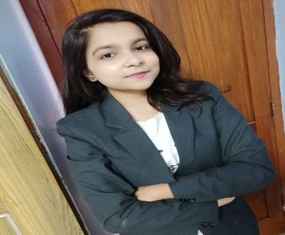
Kavita Sonwani
Computer Engineer

I am always energetic and eager to learn new skills. I am always on time for organized events, work- related or otherwise.
kavitasonwani1999@gmail.com

9399236263

Near Friend’s cafe Guru Nanak market, Vaishali nagar, Supela Bhilai (490023)

06 September ,1999

linkedin.com/in/kavita-
sonwani-39aa3b194
CAREER OBJECTIVE

A challenging position as a System Engineer where I can deploy and use my technical, academic knowledge and experience in the best possible method.

ABOUT ME

I am pretty much good with DBMS. I am always energetic and eager to learn new skills. I am a good
learner with positive attitude. I have been able to deliver a consistent approach throughout a challenging
period of development.

EDUCATION

Bachelor's Of Engineering

Chhatrapati Shivaji Institute of Technology, Durg, Chhattisgarh

08/2017 -2021, Aﬃliated to Chhattisgarh Swami
Vivekanand Technical University
, Bhilai (C.G.)

SKILLS

MYSQL

DBMS

Course-
Soft Skills- Hardworking, Team Work, Leadership, Punctuality
B. Tech in Computer Science and Engineering

HIGH SCHOOL

Krishna Public School, Sunder Nagar, Bhilai (C.G)
04/2013 - 03/2017,
Course- PCM
Class 12th, CBSE-60% Class 10th, CBSE- CGPA-7.2

EXTRA CURRICULAR

LaQshya Volunteer in D-Bugger

CSIT-Durg
(College Tech. Fest)
Participation on various competion like Singing, Dancing. (College)

LANGUAGES

English
Professional Working Proﬁciency

Hindi
Native or Bilingual Proﬁciency

INTERESTS

PERSONAL PROJECTS

CAIS (Coal Analysis and Information System)- Authentic Coal Analysis data for research and mining purpose. (07/2020 - 2021)

About the project:
Store all data about analyzed coal which is collecting form diﬀerent-2 coal producers. After analysis done by user supervisor can be update results and make the reports.
MIS execution will be there on our pages to execute monthly and weekly and yearly reports as per required by end users.

DECLARATION
Love to Explore new technologies.
I hereby declare that all the information given above is correct according to the best of my knowledge and belief.
Travelling
Music
Reading Books

