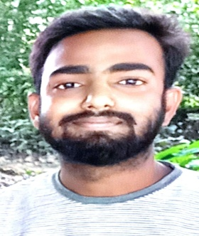
RESUME
AMIT MADDHESHIYA
Address: Ratanpur Nautanwa,
Maharajganj (U.P.) 273164
Mob.: +919616862744, +919554805949
Email id: amitmntw@gmail.com
CAREER OBJECTIVE
To get growth oriented position in a reputed organization where my skills can be experiment for important and become of me organization.
Qualification | Institute | Board | Result | Passing Year
Polytechnic Diploma 3 Year | I.T.M. Group Of Institution Maharajganj U.P. | BTEUP Board | Passed | 2021
Intermediate | V.N.J.I.C. Ratanpur Nautanwa Maharajganj U.P. | U. P. Board | Passed | 2020
High School | St. Xavier’s High School Sahajanwa Gorakhpur U.P. | CBSE Board | Passed | 2017
ACADEMIC QUALIFICATION
WORK EXPERIENCE
- Fresher
COMPUTER KNOWLEDGE
- MS. Word, MS. Excel, MS. Powerpoint
PERSONAL DETAILS
Date of Birth : 05-05-2000
Father’s Name : Ram Prakash Maddheshiya
Mother’s Name : Smt. Ishrawati Devi
Nationality : Indian
Religion : Hindu
Height : 5 fit 9 inch
Hobbies : Cricket, music
Marital Status : Unmarried
Gender : Male
Language Known : Hindi English


Date: (AMIT MADDHESHIYA)

