NAME : Dr. Florence Nagarajan 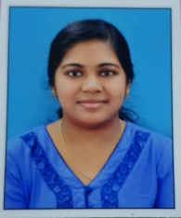
MOB : 7558877137
EMAIL ID : drflorencenagarajan@gmail.com
ADDRESS : Fleming house
Kochera po chettukuzhy
Idukki ,kerala

OBJECTIVE
Enthusiastic career oriented dental proffessional over 4+ years of experience with vast knowledge in dental care and dental services. Organized candidate successful at managing multiple priorities with a positive attitude.willing to take an added responsibilities to meet team goals and looking forward in enhancing and widening my skill set.
EDUCATION
2010 – 2016 SRM Dental College kattankulathur Chennai
Bachelor in Dental Surgery

WORK EXPERIENCE
2017 january – july Tooth care multispeciality dental clinic ( idukki)
Junior dentist
2017 october – Present Newlight Hospital (idukki)
Dental surgeon

SKILLS
- General resorative dentistrty
- Infection control maintenance
- Extraction
- Preventive care
- Crown placement
- Dental radiograph development
- X ray processing
- Scaling
- Complete denture
- Rpd
- Fpd

WORK HISTORY
- Created individualized treatment plans to maintain or restore oral health of patients
- Adviced patients on appropriate treatment for pain
- Interpreted x rays to make accurate diagnosis
- Efficiently completed all dental procedures
- Communicated with patients during consultative appointments to explain treatment plan and educate on upcoming procedures
LANGUAGES KNOWN
Malayalam, english , tamil

