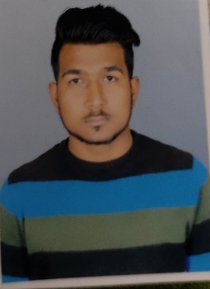
GAURAV KUMAR
Purani bazar Mahavir asthan Lakhisarai , Bihar
Email ID : coolboygaurav.2025@gmail.com
MOBILE : 9304015862

CAREER OBJECTIVE:-
To work for an organization, where I can utilize my skills with strong commitment and dedication,
for the progressive growth of the company.
EDUCATION:
Bachelor of Business Administration
Amity University Patna Year - 2020
CGPA
6.8

PUC
Loyola convent school
Ranchi Jharkhand Year – 2015
CBSE Board. Percentage
59%
S.S.L.C
Loyola convent school
Ranchi Jharkhand Year - 2013
CGPA
6.8

INTERNSHIP DETAILS
Worked in CYMATIC INDIA for 45 days on the topic of
“Marketing and Promotion of live and virtual classes of class 9th and 10th ” With special reference to SIP.

SKILLS Basic Computers, MS-Office 2007, MS excel , Power point

CERTIFICATION 1) Certificate of Cricket participate

PERSONAL QUALITIES

- Good communication skills
- Good Leadership qualities
- Ability to learn and handle the situation
- Punctuality
- Focused
- Ability to work hard and decision making qualities

EVENTS ORGANISED AND CONDUCTED
- Organized FEST in 2018
- Coordinator of sports in FEST 2019

PERSONAL DETAILS
Nationality : - Indian
Sex : - Male
Father Name : -Shambhu prasad
Mother Name : - Baby Devi
Marital Status : -Single
Languages Known : -English, Hindi
Date of Birth : -20/01/2000
Place of Birth : -Lakhisarai

DECLARATION I hereby declare that above given information is correct and true.
Place : - Lakhisarai , Bihar [Gaurav kumar]

