RESUME
Personal Details

Educational qulification
Sr. no. | Degree | Year | Board | Percentage
1. | 10th | 2017 | wbbse | 65%
2. | 12th | 2019 | wbchse | 66%
3. | Iti welder | 2021 | nsqf | 90%

Work Experience
Name:- | Chayan majumder | 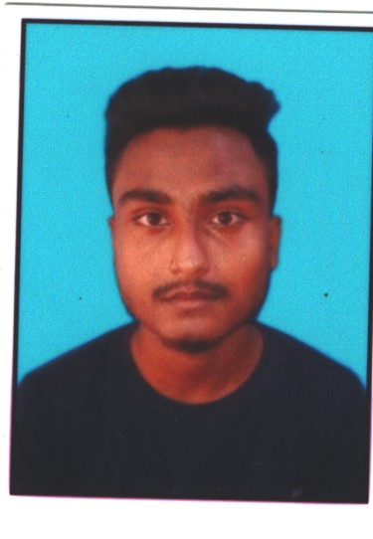
Address:- | Vill-kalipur p.o-fulia boyra. P.s-santipur. Dist-nadia. Pin-741402
Email id:- | Chyanmajumder12980@gmail.com
Mobile no:- | 8617469842
Martial status:- | Unmarried
No work experience yet
1.6thmonth computer training.
2.nsqf level123 completed.

Date:- 17/12/21

