RESUME
ARAVINTH A V
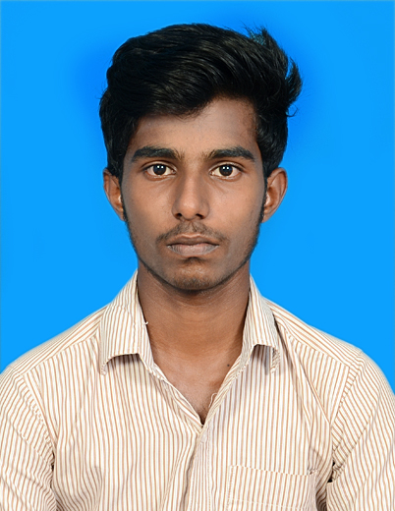
7/92A,checkkarvilai,
Mondaikadu-P.O,
Kanyakumari Dist-629252,
TamilNadu.
Mobile No : 8610759068
Email ID : aravinthronaldo2000@gmail.com
Objective:

To be part of an organization to use my knowledge and skills in
Contribute in the program of the organization as well as myself.
TECHNICAL SKILLS:

Programming Languages: c, c++,Core JAVA.
Web Designing Languages: HTML, CSS, JAVA SCRIPT
Data base: SQL, MYSQL SERVER.

Academic Chronicle:

Course | Institution | Year of Passing | Percentage
Bachelor of(Information Technology) | Leshmipuram college of arts&science(MSU) | 2020 | 81%
HSC | Devasom Higher Secondary School, Mondaikadu  (State Board) | 2017 | 80%
SSLC | Devasom Higher Secondary School, Mondaikadu  (State Board) | 2015 | 82%

Hobbies :

- Cricket
- Riding Bike

Personal Details :

Father Name : M. Appaswamy
Date of birth : 16 – 06 - 2000
Nationality : Indian
Sex : Male
Marital status : Single
Languages known : English, Tamil.
Declaration

I hereby declare that the information furnished above is true to my knowledge.

Place: Mondaikadu Signature
Date :

(Aravinth A V)
s

